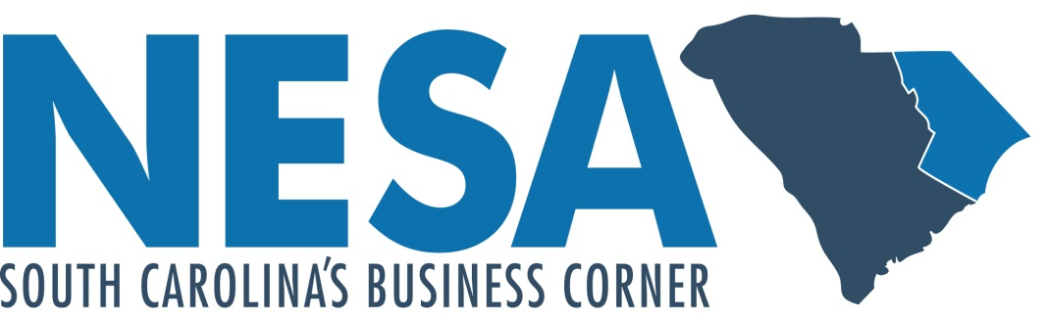

**2018 Annual Report**

**Local Economic Development Alliances Appropriation**

**Proviso 50.13**

Annual Report – LEDA Appropriation

In accordance with the guidelines for the proviso, the appropriation to Local Economic Development Alliances (LEDA), this shall serve as a report relative to the use of this funding by the North Eastern Strategic Alliance (NESA). All of the required documentation necessary through receipt of these funds has been submitted to the Department of Commerce.

Programs adhering to the guidelines of the appropriation for the expenditure of these funds were developed and adopted by the NESA Executive Committee. The following is an outline of and progress report for the programs that were approved by the NESA Executive Committee and submitted and accepted by the South Carolina Department of Commerce.

# Grant Program for County Business Development

The NESA Executive Committee developed a financial assistance program to encourage investment in product development and marketing programs that enhance the region’s competiveness.

All of the NESA counties are eligible to receive funding for marketing and product development efforts that are intended to promote job creation. Eligible projects include speculative buildings, site acquisition, on-site infrastructure, industrial site planning and due diligence, South Carolina certified site documentation, industrial park amenities, site brochures, website development or enhancements, quality of life brochures, DVD’s and other projects that have the potential to create jobs as approved by NESA on a case by case basis. Counties receiving grant funds signed a certification form stating the following:

1. That their project was executed in accordance with the South Carolina Consolidated Procurement Code
2. That they will maintain all records pertaining to the use of these funds for a period of three fiscal years
3. That they acknowledge the fact that their records are subject to audit by the South Carolina Department of Commerce and the State Auditor’s Office
4. That they acknowledge the fact that by receiving these funds they are subject to the South Carolina Freedom of Information Act and that they will comply with public disclosure and other requirements under state law

Collaborative Product Development

NESA will work with county allies, board members and private sector sponsors to identify worthwhile economic development product and infrastructure projects within the region. The program will induce, leverage and maximize funding from the private sector in order to develop sites, buildings, and other infrastructure within the region which will assist us in being more competitive for economic development projects.

Marketing and Business Development

These funds will be used to promote the NESA region for economic development opportunities through marketing, lead generation, and business development efforts. In accordance with our mission to create jobs, NESA will proactively contact and meet with key site selection consultants and corporate executives of companies that would consider the NESA Region a viable option for new facilities.

**NESA Mission and Goals**

Our primary objective is to create jobs and improve the lives for the residents of the 9 county region by working within the existing industry base and recruiting new companies.

Included are metrics to reflect progress in the NESA region:

Below reflects the changes in jobs in 2018 through August; a net increase of 4.99% in the NESA region as compared to the state. Also depicted is SC percent growth removing the NESA region, reflecting the positive impact of job growth in the NESA region on our state.



Furthermore, percent unemployment has experienced a net decrease of 2.30% from Jan to Aug 2018 in the NESA region. This compares to only a 1% decrease statewide through the same time period.





Job recruitment in the NESA region increased 54% between 2016 and 2017, which is 13 percentage points higher as compared to the state. Capital investment per capita increased 348% between 2016 and 2017, which is 296 percentage points higher than the state.



Per capita income in the NESA region increased by 3.8% between 2015 and 2016, which is 0.1 percentage points higher than the state and 0.7 percentage points higher than the nation.

**Financial Report**

**As of September 30, 2018**



**Accounting and Administration**

NESA uses cash basis accounting and will comply with quarterly and annual reporting requirements including the provision of financial statements. NESA is in good standing with regard to its administration of the previous state match programs. NESA will contract with an independent auditor on an annual basis to review all of its accounts including the state match program accounts.